**Torque – Inertia Relation and Mechanical Setup Analysis for**

**DT4260-24-055-04H-PT 24VDC 4000RPM 1814-0067MOTOR (telcointercon) BLDC of DRV8312EVM KIT**

This document is prepared for mechanical construction of BLDC motor to flywheel system. Wheel dimension and mass with respect to desired motion profile is analyzed.

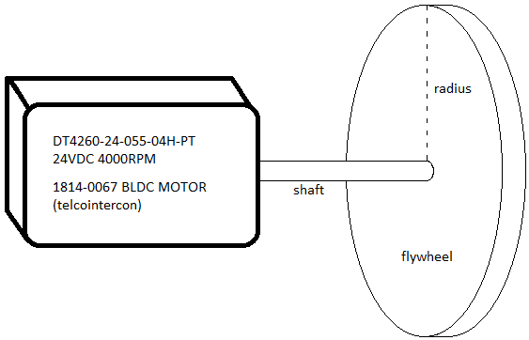

Fig.1: Desired Setup

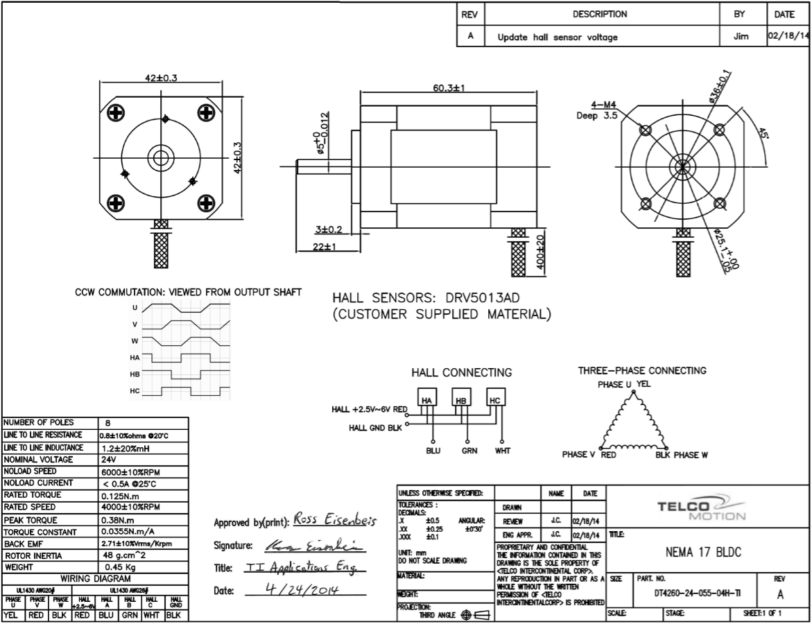

Fig.2: Motor Specs

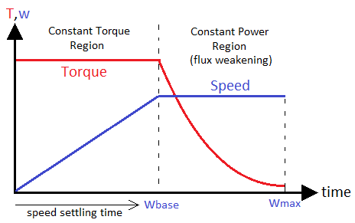

Fig.3: Desired torque-speed curve

The shaft torque ($T, Nm$), desired speed $(w, rad/s)$ and flywheel inertia ($J, kg/m^{2}$) relation is given in below eq. Lets take the target speed as 4000rpm (418.87 rad/s) (rated speed of BLDC) for 5sec settling time. Rated torque of the BLDC is 0.125Nm.

$$T=J\frac{dw}{dt}=0.125Nm=J\frac{418.87 rad/s}{5sec} →J=1.49×{10}^{-3} kgm^{2}$$

The flywheel disc dimensions:

$$\frac{1}{2}mr^{2}=0.00149 kgm^{2}$$

If we limited the radius as 0.1m, $→m_{flywheel}=0.29 kg$

Table.1: Flywheel calculation table

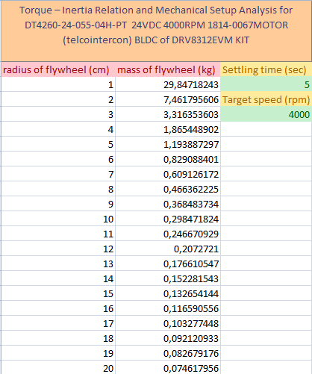

[DRV8312EVM Flywheel setup calculator.xlsx](DRV8312EVM%20Flywheel%20setup%20calculator.xlsx)